# Tutorial 7

**Reading a CSV file into a Pandas Data Frame:**

Df.describe()

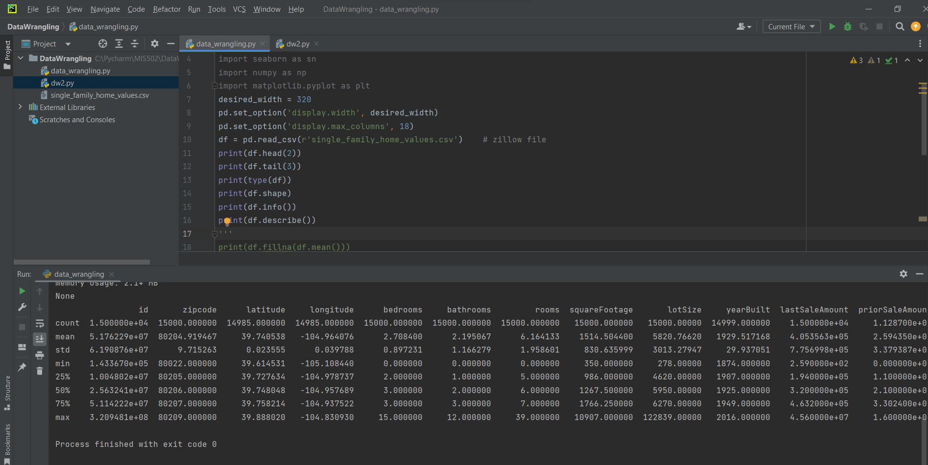

Median

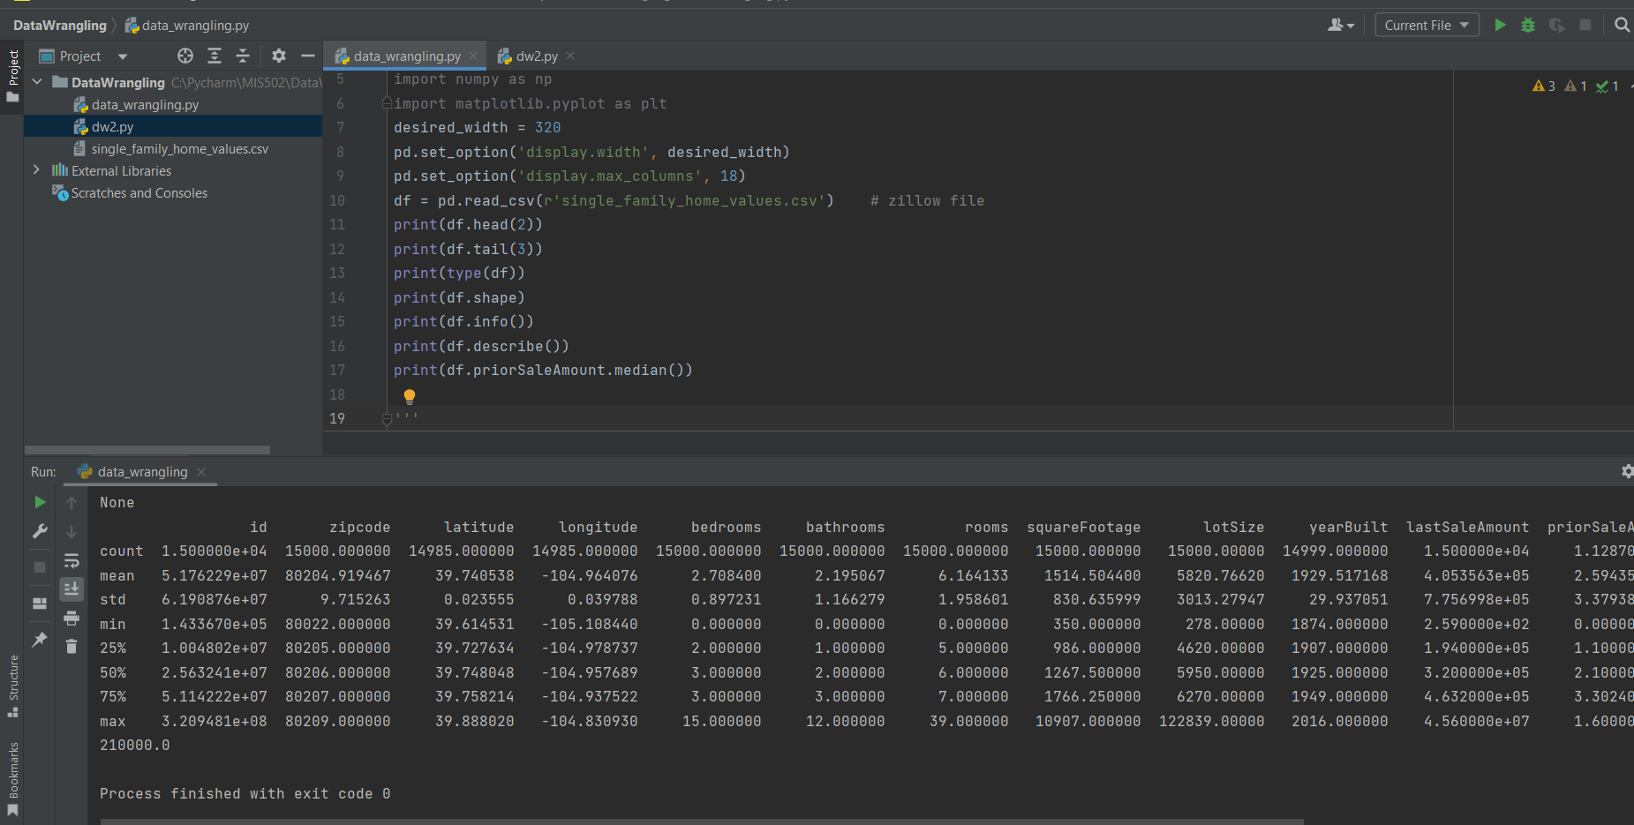

**Dealing with missing data and outliers:**

**Simple Statistics in Python:**

**Slicing a DataFrame:**

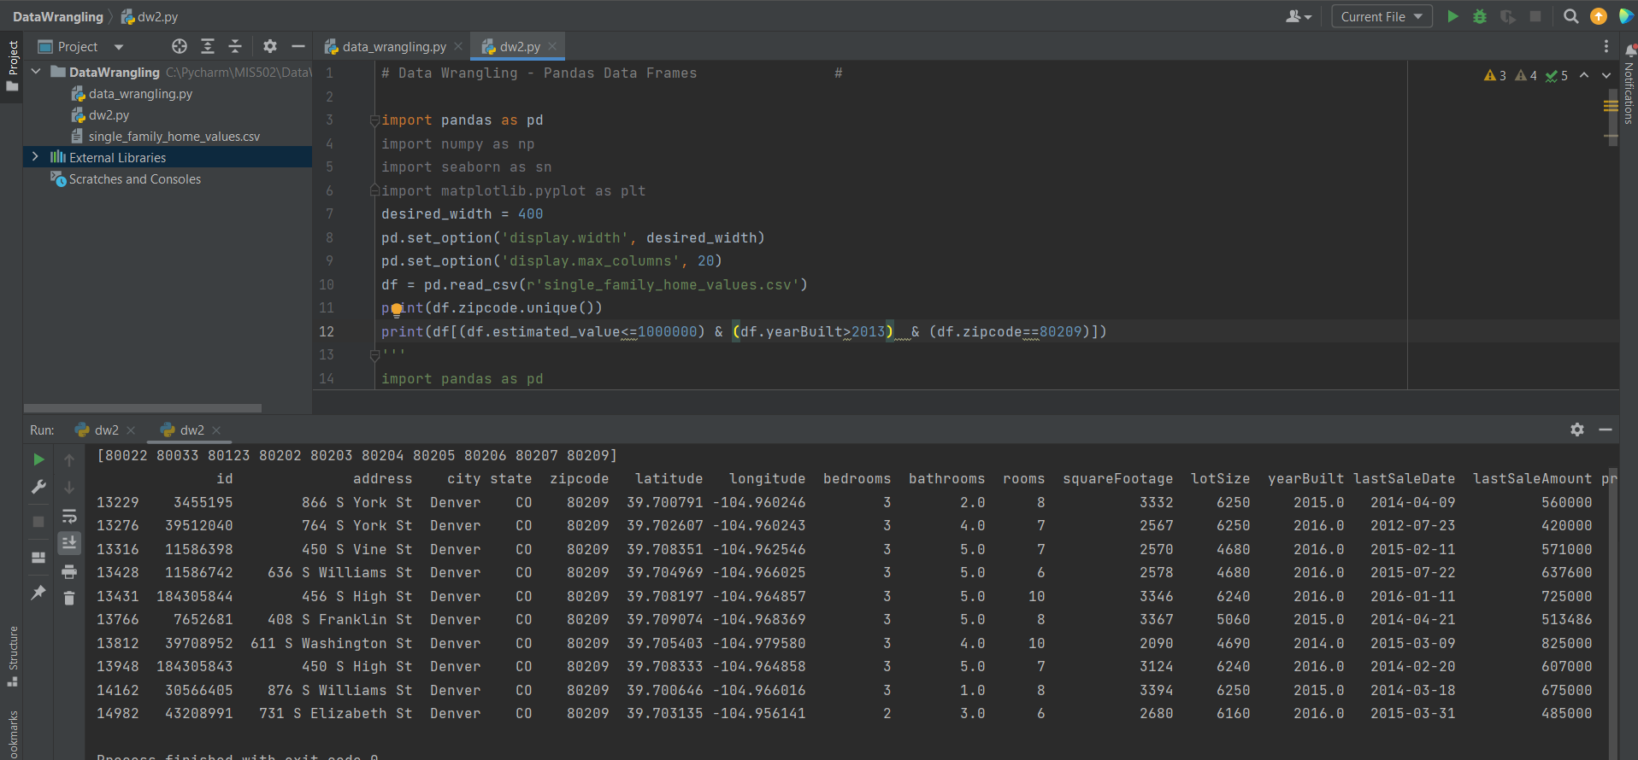

Groupby merge etc.

